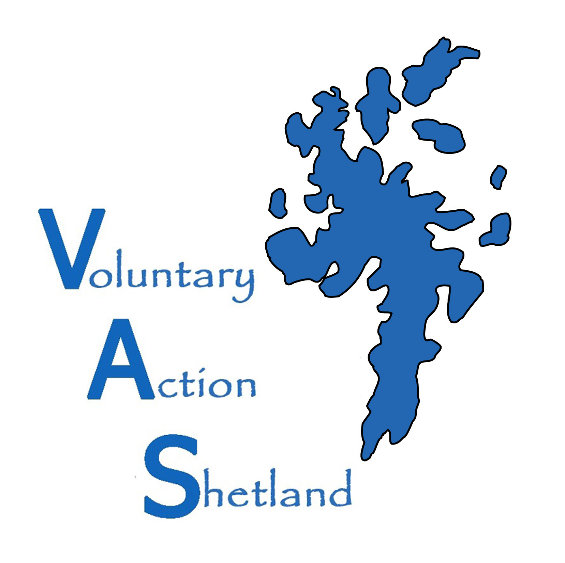
Volunteer Opportunity Registration Form

DEFINITION OF VOLUNTEERING:

Volunteering represents a valuable contribution to society which helps deliver stronger, more resilient, communities
1. Volunteering is a free will activity. It must not be undertaken through coercion and under no circumstances can it be mandatory.
2. It is not undertaken for financial gain. Outwith reasonable expenses there must be no financial transaction to encourage someone to volunteer.
3. It is a public and civil good undertaken for the benefit of the community, society at large or an individual other than the volunteer.

MAIN DETAILS
Title of Opportunity
Name of Organisation
Contact Name
Contact Address (including postcode)
Contact Telephone Number
Contact Email

DESCRIPTION OF OPPORTUNITY

TRAVEL DETAILS
Where does the opportunity take place?

TYPE OF VOLUNTEERING OPPORTUNITY
Administration/Office opportunity |  | Counselling |  | Playschemes/Childrens’ clubs
Advice/Information giving |  | Disaster/Emergency relief |  | Online volunteering
Advocacy/Human rights |  | Driving/Escorting |  | Practical/DIY
Arts (music/drama/crafts) |  | Equal opportunities/Race relations |  | Research/Policy making
Befriending/Mentoring |  | Finance/Accounting |  | Residential volunteering
Campaigning/Lobbying |  | Fundraising |  | Short term/Seasonal volunteering
Care/Supporting |  | Homebased volunteering |  | Specialist/Technical
Catering |  | Justice/Legal assistance |  | Sports/Outdoor activities
Charity shops/Retail |  | Languages/Translating |  | Tutoring/Supporting learners
Committee volunteering |  | Library/Information management |  | Volunteering for under 16s
Community/Economic dev |  | Management/Business skills |  | Youth volunteering
Computing |  | Marketing/PR/Media
Conservation/Gardening |  | Miscellaneous

WHICH OF THE FOLLOWING ISSUES BEST MATCHES YOUR VOLUNTEERING OPPORTUNITY?
Animals |  | Learning Disabilities |  | People With Ill Health
Anti Poverty |  | LGBT |  | Physical Disability
Arts (music/drama/crafts) |  | Literacy Needs |  | Refugee/Asylum Seeker
Carers |  | Local Authority |  | Religion/Faith
Children (0-11) |  | Local Community |  | Residents of Disadvantaged  Neighbourhoods
Crime and Safety |  | Lone Parents |  | Residents of Disadvantaged  Neighbourhoods
Disaster/Emergency |  | Low Income Households |  | Sensory Impairment
Drugs/Alcohol |  | Mental Health |  | Sport/Outdoor Activity
Education/Literacy |  | Men’s Groups |  | Tackling Unemployment
Elderly |  | Miscellaneous |  | Travellers and Gypsies
Environment |  | Museums/Galleries/Heritage |  | Unemployed
Ethnic Minorities |  | Offenders and Ex Offenders |  | Victims of Crime
Families |  | Overseas/Developing World |  | Women’s Groups
Health/Hospitals/Hospices |  | Parents |  | Young People (12-25)
Homelessness/Housing |  | People Affected by Disaster
Human/Civil Rights/Justice |  | People Not at School

FUNDING – Who funds the opportunity?
Business Sector |  | Donations |  | Local Enterprise Company
Central Gov – Scottish Gov |  | Earned Income |  | Lottery Boards
Central Gov – Westminster Gov |  | European Money |  | Other
Charitable Trust |  | Health (Board/Trust)
Communities Scotland |  | Local Authority

OPPORTUNITY DETAILS
Minimum age you accept volunteers |  | Maximum age you accept volunteers
What skills, attitudes, experience, qualifications does a person need to do this volunteering opportunity?

Number of volunteers required
When does the opportunity start? |  | Is there an end date?
When does the opportunity take place? (Days of the week – times)

Are expenses paid? |  |  | YES/NO
What types of insurance covers this opportunity?
Is there a taster session available? |  |  | YES/NO
Will the volunteer be offered training? |  | Induction training | YES/NO
 |  | Ongoing training | YES/NO
 |  | Named support for volunteer | YES/NO
Is childcare available? / Are childcare costs available for the volunteer? |  |  | YES/NO
Is there wheelchair access where the opportunity takes place? |  |  | YES/NO
Are there wheelchair accessible toilets where the opportunity happens? |  |  | YES/NO
Are volunteer expenses paid (e.g. travel) |  |  | YES/NO

APPLICATION PROCESS – Which methods do you use?
Application form |  | Induction / training |  | Informal chat
Interview |  | PVG |  | References
Trial period |  | Other

The information you have given will help us signpost prospective volunteers to your organisation, and to monitor and improve the quality of our services. The information will be entered on our database and shared with potential volunteers. The volunteering opportunity will appear on our website, social media platforms and on other third party volunteer opportunity portals (such as Volunteer Scotland). This is to help maximise the reach of your opportunity.

I HAVE READ THE INFORMATION ABOVE AND I CAN CONFIRM THE DETAILS ARE CORRECT.
I HAVE READ AND UNDERSTOOD AND AGREE TO THE DATA-SHARING NOTIFICATION.

Please tick how you would like us to contact you (tick all that apply)
Post Email Telephone

I am authorised to sign this on behalf of my organisation:

NAME___________________________________________________________________________________

SIGNATURE______________________________________________________________________________

POSITION IN ORGANISATION______________________________________ DATE_____________________

Thank you for completing this form. Please keep a copy for your own records.

Voluntary Action Shetland
Market House, 14 Market St, Lerwick, Shetland. ZE1 0JP
01595 743910 Kathleen.williamson@shetland.org
www.va_shetland@shetland.org

Voluntary Action Shetland is a charitable company limited by guarantee registered in Scotland No 165677 Registered Office Market House, 14 Market St, Lerwick, Shetland. ZE1 0JP. Registered Scottish Charity No SC017286

