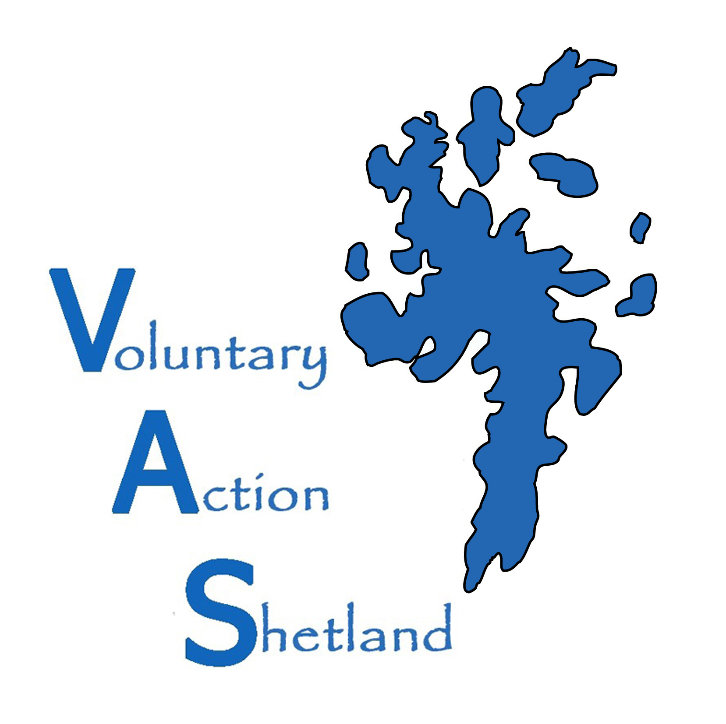
Volunteer Organisation Registration Form

ORGANISATION DETAILS
Organisation Name
Organisation Address (including postcode)

Organisation Telephone Number
Organisation Email
Organisation Web Address
ORGANISATION CONTACT
Contact Name for Organisation
Contact Address (including postcode)
Contact Telephone Number (daytime)
Contact Mobile Number
Contact Email
Position in Organisation

TYPE OF ORGANISATION
Voluntary Organisation |  | Private |  | Statutory
Educational Establishment |  | Partnership / Network |  | Social Enterprise
Place of Worship |  | Uniformed Group

REGISTERED CHARITY
Are you a registered charity | YES/NO | Charity Number (if yes)

WHICH OF THE FOLLOWING BEST DESCRIBES YOUR ORGANISATIONS ACTIVITIES?
Animals |  | Learning Disabilities |  | People With Ill Health
Anti Poverty |  | LGBT |  | Physical Disability
Arts (music/drama/crafts) |  | Literacy Needs |  | Refugee/Asylum Seeker
Carers |  | Local Authority |  | Religion/Faith
Children (0-11) |  | Local Community |  | Residents of Disadvantaged  Neighbourhoods
Crime and Safety |  | Lone Parents |  | Residents of Disadvantaged  Neighbourhoods
Disaster/Emergency |  | Low Income Households |  | Sensory Impairment
Drugs/Alcohol |  | Mental Health |  | Sport/Outdoor Activity
Education/Literacy |  | Men’s Groups |  | Tackling Unemployment
Elderly |  | Miscellaneous |  | Travellers and Gypsies
Environment |  | Museums/Galleries/Heritage |  | Unemployed
Ethnic Minorities |  | Offenders and Ex Offenders |  | Victims of Crime
Families |  | Overseas/Developing World |  | Women’s Groups
Health/Hospitals/Hospices |  | Parents |  | Young People (12-25)
Homelessness/Housing |  | People Affected by Disaster
Human/Civil Rights/Justice |  | People Not at School

WHAT ARE THE MAIN AIMS AND OBJECTIVES OF YOUR ORGANISATION?

DOES YOUR ORGANISATION HAVE THE FOLLOWING POLICIES?
Equal Opportunities Policy |  | Health and Safety Policy
Volunteer Policy |  | Child Protection Policy
Vulnerable Adults Policy |  | Equality and Diversity Policy
CRBS Registered

Here at Voluntary Action Shetland we take your privacy seriously and will only use your personal information to administer your account. From time to time we would like to contact you to monitor and improve our service, and also to provide you with information on our services. The information on this form will be held on our database and shared with potential volunteers who are interested in volunteering with you.

I HAVE READ THE INFORMATION ABOVE AND I CAN CONFIRM THE DETAILS ARE CORRECT.
I HAVE READ AND UNDERSTOOD AND AGREE TO THE DATA-SHARING NOTIFICATION.

Please tick how you would like us to contact you (tick all that apply)
Post Email Telephone

I am authorised to sign this on behalf of my organisation:

NAME___________________________________________________________________________________

SIGNATURE______________________________________________________________________________

POSITION IN ORGANISATION______________________________________ DATE_____________________

Thank you for completing this form.
Please keep a copy for your own records and return it to the details at the bottom of this form.

DEFINITION OF VOLUNTEERING:
Volunteering represents a valuable contribution to society which helps deliver stronger, more resilient, communities
1. Volunteering is a free will activity. It must not be undertaken through coercion and under no circumstances can it be mandatory.
2. It is not undertaken for financial gain. Outwith reasonable expenses there must be no financial transaction to encourage someone to volunteer.
3. It is a public and civil good undertaken for the benefit of the community, society at large or an individual other than the volunteer.
Voluntary Action Shetland
Market House, 14 Market St, Lerwick, Shetland. ZE1 0JP
01595 743910 Kathleen.williamson@shetland.org
www.va_shetland@shetland.org

Voluntary Action Shetland is a charitable company limited by guarantee registered in Scotland No 165677 Registered Office Market House, 14
Market St, Lerwick, Shetland. ZE1 0JP. Registered Scottish Charity No SC017286

