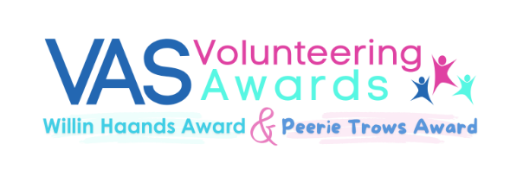

NOMINATION FORM

Do you know anyone who deserves a thank you for helping out in their community, someone who quietly helps other folk, someone who helps at community events, volunteers with an organisation, a community stalwart?
If you would like to say thank you or recognise someone for all their efforts then please complete this nomination form. Please let us know your (the nominator’s) details in Section 1 and continue with the details of the person you are nominating in Section 2.

I am nominating:
A child - 11 years and under (Peerie Trows Award)

An adult - 26 years and over (Willin Haands Award)

Section 1 – Your (the Nominator’s) Contact Details
First Name Last Name

Phone Number Email Address

Address
Postcode

Section 2 – Volunteer’s Contact Details (if nominating a child, please enter parent or guardian’s email address and phone number)
First Name Last Name

Phone Number Email

Address
Postcode:
Peerie Trows Award (children 11 and under) only: Date of Birth (if exact DOB unknown, please let us know the child’s age)

Section 3 – Please tell us why you are nominating this person for a VAS Volunteering Award.

Section 4 – Consent, Signature and Confirmation

I hereby declare that I have read the rules and criteria of this award. I confirm that all the
information provided for this nomination is, to the best of my knowledge, correct and true. I also hereby consent to being contacted by Voluntary Action Shetland in relation to my nomination.

Signature:

Print Name Date

Definition of Volunteering:

Volunteering is a freewill activity which benefits the community, society at large or an individual other than the volunteer or a member of the volunteer’s family, there should not be an expectation to do it. It is not undertaken for financial gain. No payment can be made to volunteers, except reimbursement of reasonable expenses.
You can access our Data Protection notice by request or on our website www.voluntaryactionshetland.com.

For evaluation purposes: How did you hear about the VAS Volunteering Awards? (please highlight)
Poster / Direct Email / SIBC Advert / Online News Article / Newspaper / Facebook / Word of Mouth / Other





